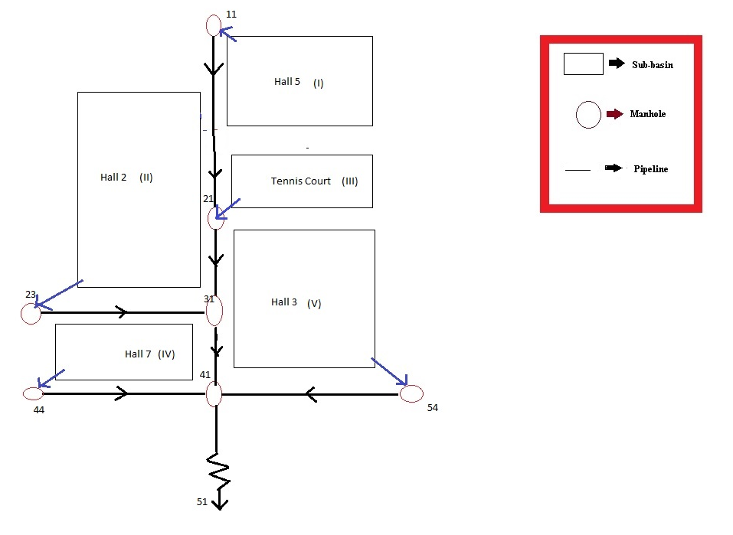

1. The excel file given in the folder contains annual maximum rainfall data of various durations for 60 years. Try to fit Log-Normal and Gumbel’s distribution to the data. Use the best-fit distribution for estimating the frequencies. Plot the intensity duration frequency curves corresponding to 2, 5, 10, 25 and 50 years of return periods, respectively. Once the IDF data are obtained, fit equation of the form: $i_{D, T}=\frac{K*T^{x}}{{\left(D+a\right)}^{n}}$ where, *D* is the duration of the storm in minutes and *T* is the return period of the storm event in years.
2. Design the storm water drainage system for 5 years return period. Provide uniform triangular gutter section with curb opening inlet. Assume single lane service road with longitudinal slope of 0.0015 and cross slope of 0.035. Use the Rational formula for calculating the peak discharge and the kinematic wave approximation for the time of concentration. Also assume no by-pass flow while designing the inlet.
3. Using statistical method, compute the probable maximum 12-h precipitation with a return period of 500 years.
4. Develop the hyetograph for 2-hour storm of 20-year return period using alternating block method with 15-time intervals.
5. Check the adequacy of your design for the storm event in (d). If your design is inadequate, estimate the extent of water logging in the vicinity.

|  |  |  |  |  |  |  |
| --- | --- | --- | --- | --- | --- | --- |
| **Basin** | **Area of the basin**  **(Hectares)** | **Division of basin area (%)** | | **Drainage Length**  **(m)** | **Slope of the basin** | **Manning’s coefficient for basin** |
| **I** | 0.9 | Residential | 58 | 87.2 | 0.009 | 0.039 |
| Lawn and open space | 32 |
| Paved street roads | 10 |
| **II** | 0.85 | Residential | 60 | 85.6 | 0.008 | 0.032 |
| Lawn and open space | 32 |
| Paved street roads | 8 |
| **III** | 0.4 | Residential | 40 | 40.3 | 0.01 | 0.025 |
| Lawn and open space | 50 |
| Paved street roads | 10 |
| **IV** | 0.84 | Residential | 65 | 83.2 | 0.012 | 0.03 |
| Lawn and open space | 27 |
| Paved street roads | 8 |
| **V** | 0.9 | Residential | 55 | 86 | 0.0013 | 0.035 |
| Lawn and open space | 35 |
| Paved street roads | 10 |

|  |  |  |
| --- | --- | --- |
| **Pipeline** | **Length of pipeline (m)** | **Avg. slope** |
| 11-21 | 1000 | 0.002 |
| 21-31 | 400 | 0.0035 |
| 31-41 | 500 | 0.001 |
| 23-31 | 600 | 0.004 |
| 44-41 | 600 | 0.0032 |
| 54-41 | 700 | 0.0042 |

|  |  |
| --- | --- |
| **Manhole** | **Reduced level of the Manhole (m)** |
| 11 | 137.1 |
| 21 | 136.5 |
| 31 | 133.2 |
| 41 | 129.5 |
| 23 | 131.6 |
| 44 | 132.2 |
| 54 | 132.6 |

**Note:- You can make any other assumption(s), if necessary, beyond the code provisions. Make sure to mention the same in the final report.**